**Google Data Studio Screen Shot**

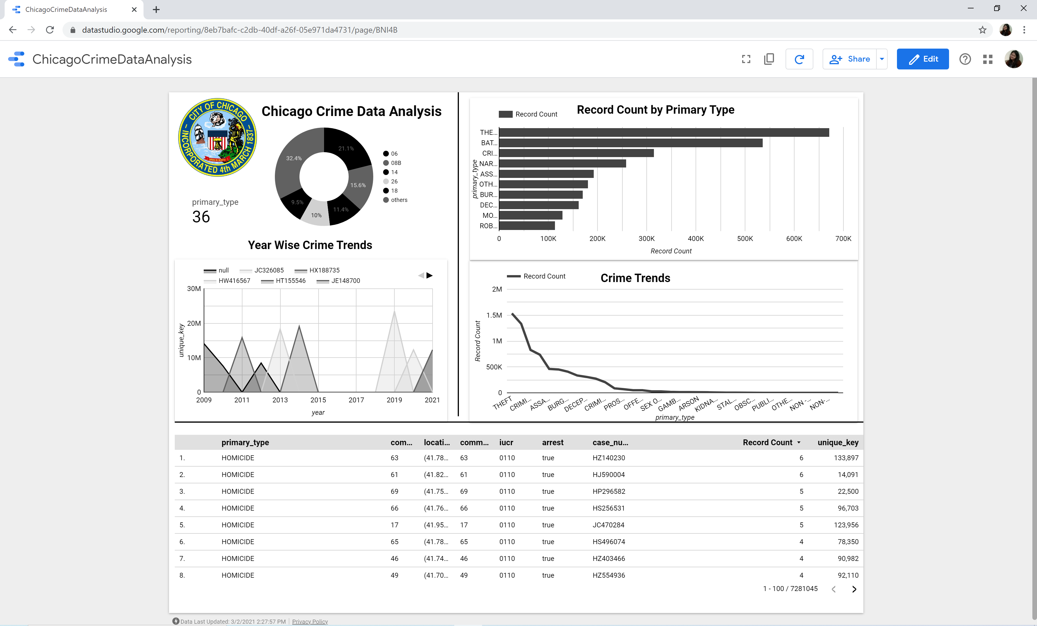

**Crime Type By Year:  
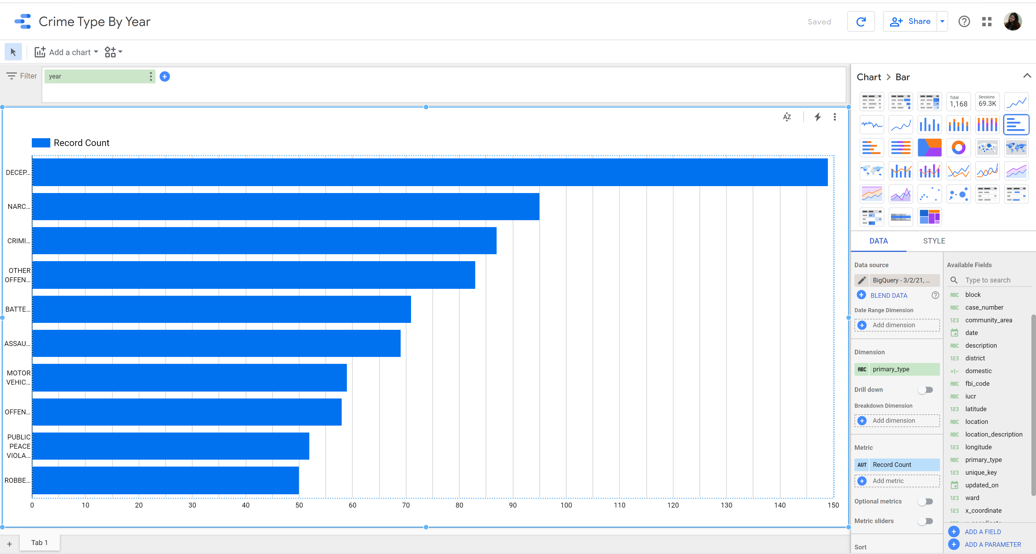**

**Crime Type by Year 2019**

